**A NOVEL HYBRID NANOCOMPOSITE FOR**

**ELECTROCHEMICAL SENSING OF LEAD IONS USING**

**REDUCED GRAPHENE OXIDE/ CERIUM OXIDE**

**SURFACE MODIFIED WITH *Calotropis gigantae***

**A PROJECT REPORT**   
 ***Submitted by***

**NITHISH K (711518214017)**   
 **SUDHIR R (711518214027)**   
 **YUGENTHAR M (711518214036)**

***in partial fulfillment for the award of the degree***

***of***

**BACHELOR OF TECHNOLOGY**

**in**

**BIOTECHNOLOGY**



**KIT-KALAIGNARKARUNANIDHI INSTITUTE OF TECHNOLOGY,**   
**COIMBATORE – 641 402**

(An autonomous institution affiliated to Anna University, Chennai)



**ANNA UNIVERSITY, CHENNAI – 600 025**   
 **MAY 2022**

**DECLARATION**

We do hereby declare that the work titled “**A novel hybrid nanocomposite for electrochemical sensing of Lead ions using reduced Graphene oxide/ Cerium oxide surface modified with *Calotropis gigantae*”** is the project work of **Nithish K** (711518214017), **Sudhir R** (711518214027)and **Yugenthar M** (711518214036), carried under the guidance and supervision of **Dr. Tha. Thayumanavan**, Professor and head, Department of Biotechnology and under the co-guidance of **Dr. P. Senthil kumar**, Professor, Department of Chemical Engineering, SSN College of Engineering, Chennai and this work has not been submitted elsewhere for any other Degree/ Diploma/ Associateship/ Fellowship/ Titles in this or any other university or similar institution of higher learning.

Place: Coimbatore Signature of the candidates Date:

Nithish K (711518214017)

Sudhir R (711518214027)

Yugenthar M (711518214036)

**ACKNOWLEDGEMENT**

At this delightful moment of having accomplished our project we extend our sincere thanks to **Thiru. Pongalur N. Palanisamy**, *Founder Chairman* and **Thiru. P. Pynthamil**, *Chairman,* KIT- KalaignarKarunanidhi Institute of Technology, for providing amenities and lab facilities for completing the project work.

We extend our sincere thanks to **Mrs. Indu Murugesan,** *Vice Chairperson*, (Late) **Dr. A. Vidhya Gokul**, *Managing Trustee*and **Mr. A. Suriya**, *Executive Trustee* ofKIT- KalaignarKarunanidhi Institute of Technology, for empowering us with excellent infrastructure and able administration.

We wish to express our sincere gratitude to our beloved **Dr. N. Mohan Das Gandhi,** *Principal,* for providing us an opportunity and essential facilities in carrying out this project. Also, we wish to articulate our sincere thanks to **Dr. M. Ramesh**, *Vice Principal,* for his support and encouragement to carry out this project.

We wish to express our sincere thanks to our Supervisor, **Dr. Tha. Thayumanavan,** *Professor & Head,*Department of Biotechnology, for his implausible moral support throughout the project that have been invaluable for the project development and improvement.

Our sincere thanks to Co-*Supervisor* **Dr. P. Senthil kumar**, Professor, Department of Chemical Engineering, SSN College of Engineering, Chennai,for his incredible guidance and help in our project and his associates Dr. K. Krishna kumar and Dr. G. Padmalaya for their valuable support.

We thank SEM analysis laboratory, Central work shop, **Anna University** for providing the SEM analysis facility.

We also wish to express our gratitude to **Ms. R. Karthikapriya**, *Project Coordinator* and*Assistant Professor* for her extended support and suggestions throughout the project.

Finally, we thank our **parents** for their love and support.

**4**

**TABLE OF CONTENT**

**Chapter No. Title Page No.**

1. **ABSTRACT 6**
2. **LIST OF FIGURES 7**
3. **LIST OF ABBREVIATIONS 8**
4. **INTRODUCTION 9**
5. **AIM AND OBJECTIVE** 
   1. Aim **11**
   2. Objective **11**

**6 EXPREMENTAL PROCEDURES**

**6.1** Materials **12**

**6.2** Equipment’s **12**

**6.3** Preparation of GO **12**

**6.4** Preparation of CeO2  **13**

**6.5** Preparation of GO/CeO2 **13**

**7 RESULTS AND DISCUSSIONS**

**7.1** X-ray diffraction analysis **14**

**7.2** FT-IR studies **15**

**7.3** SEM analysis **15**

**7.4** Electrochemical sensing

**7.4.1** Cyclic voltammetry studies **16**

**7.4.2** Square wave voltammetry studies **17**

**8 CONCLUSION 21**

**9 REFRENCE 22**

**5**

1. **ABSTRACT**

A novel hybrid nanocomposite has been synthesized via a green route. Reduction and capping of Graphene oxide and Cerium oxide nanocomposite (GO/CeO2) has been achieved by the usage of milky latex of a native plant species *Calotropis gigantae*. Cyclic voltammetry technique helped in analysing the redox activity of the prepared nanocomposite. Characterization of the nanocomposite was studied using SEM, FT-IR, X RD spectroscopy. The electrode modified with the nanocomposite was employed for the detection of lead ions at a microscale concentration by the square wave voltammetry technique (SWV). For detection of lead ions, parameters such as pH and concentration of the analyte in the electrolyte solution were taken into consideration and optimised to obtain sensitivity of 1.76 pg/L/µA and LOD of 16.8 ng/L.

Keywords: green synthesis, nanocomposite, lead ions, square wave voltammetry.

**6**

**2. LIST OF FIGURES**

___________________________________________________________________________

**S No. Description Page no.**

1. X-Ray Diffraction of CeO2, rGO/CeO2  **14**

rGO/CeO2/Latex nanocomposite

1. FTIR spectra analysis of procured electrode **15**

nanomaterials

1. SEM images of rGO sheets, CeO2 nanoparticle, **16**

rGO/CeO2, rGO/CeO2/Latex nanocomposite

1. Ferrocyanide response of GO modified GCE, **17**

CeO2 modified GCE, rGO/CeO2 modified GCE, rGO/CeO2/Latex modified GCE

1. pH response of Lead ions using GO/CeO2/Latex **18**

modified GCE

1. Square Wave Voltammetric sensing of Lead ions **19**

using GO/CeO2/Latex modified GCE

1. Linearly plotted graph against the lead ions **19**

concentration and peak current

1. Experimental three electrode setup for cyclic **20**

voltammetry and square wave voltammetry

____________________________________________________________________________

**7**

**3. LIST OF ABBREVATIONS**

**S.No. Abbreviation Expansion**

**1.** ml milliliter   
**2.** µl microliter   
**3.** ºC Degree Celsius

**4.** mg milligram

**5**. rpm Revolutions per minute   
**6**. rGO Reduced Graphene oxide

**7.** CeO2 Cerium oxide

**8.** nm Nanometer

**9.** CV Cyclic voltammetry

**10.** SWV Square wave voltammetry

**11**. XRD X-Ray diffraction

**12.**  FT-IR Fourier transform infrared

**13.** SEM Scanning electron microscope

**8**

**4. INTRODUCTION**

Nanomaterials have acquired tremendous momentum in the present rapidly emerging scientific era, it has been proven to possess numerous application which are employed due to their characteristic shape, area, size and surface chemistry[1]. The material properties get altered when the bulk sizes are reduced to nanoscale that can lead to several unique mechanical, optical and physicochemical properties. Furthermore, because of their multifunctional ability nanoparticles has been used in numerous application such as batteries, supercapacitors, removal of toxic pollutants/ heavy metals, drug delivery [2-5]. In the present study, we attempted to synthesis reduced Graphene oxide decorated with cerium oxide by green route for electrochemical sensing of lead ions.

Heavy metal pollution can cause harmful effects on human beings[6]. Due to mining, agricultural pollution, industrial activities heavy metals are present in the upper crust of the earth surface. High dose exposure of heavy metals [7] like lead can induce several health issues such as kidney failure, neuropsychiatric disorders, bloody diarrhoea, anaemia, renal impairment. Even at low concentration lead can manifest haematological and neurological toxicity. Various nanoparticles such as gold, silver, zinc, silica are used to detect lead ions[5, 8-12]. Among various nanomaterials reduced Graphene oxide (rGO) hybridized with different nanoparticles created remarkable interest among enormous scientific researches due to their promising catalytic ability and multifunctional hybrid properties.

rGO reinforced with rare earth metal oxides show great catalytic behaviour, among various classes of earth oxides, cerium oxide possess high mechanical strength and biocompatibility[13]. Due to its good optical property, high mechanical strength, good biocompatibility, unique catalytic property and electronic

**9**

configuration of CeO2, it acts as a suitable support material for Graphene oxide[14, 15]. The usage of GO/CeO2 nanocomposites in electrochemical sensing have earned greater attention due to its numerous advantages such as affordability, large surface area, high sensitivity and selectivity, altered adsorption properties[16]. These kind of hybrid nanoparticles attained remarkable interest due to their unique properties.

For the preparation of rGO/CeO2 nanocomposites the present study employed a green synthesis method. Green synthesis method is considered to be an eco-friendly method and preferred for its feasibility and low cost[17, 18]. In this research work, the plant *Calotropis gigantae* have been used to synthesis rGO/CeO2 nanocomposites.

Due to its abundance and chemical properties various nanomaterials have been synthesized such as magnesium oxide, nickel oxide, titanium dioxide, Zinc oxide, Silver oxide and cupric oxide[19-23]. *Calotropis gigantae* produces milky latex that express various medicinal properties[24]. Few studies have been carried out using milky latex of *Calotropis gigantae* to synthesis nanoparticles. This study deals with synthesis of rGO/CeO2 nanocomposites by using milky latex extracted from the branches of *Calotropis gigantae*.

The hybridized rGO/CeO2 nanocomposites is characterized using scanning electron microscope, Fourier-transform infrared (FT-IR) spectroscopy, X-ray diffraction (XRD) spectroscopy. Furthermore, the hybrid potential of rGO/CeO2 nanocomposites synthesized by green method is measured by using electrochemical sensing of lead ions[25].

**10**

**5.1 Aim**

**5. AIM AND OBJECTIVE**

To develop a hybridized GO/CeO2 nanocomposite by green synthesis method for lead ions detection.

**5.2 Objective**

• To reinforce rGO with metal oxides in lanthanide series.

• To synthesis nanocomposite by green route method.

• To detect lead ions using nanocomposite by cyclic voltammetry and

square wave voltammetry studies.

**11**

**6. EXPERIMENTAL PROCEDURE**

**6.1 Materials:**

Milky latex of *Calotropis gigantae* was collected from healthy plants. Concentrated Sulphuric acid, Hydrochloric acid and Hydrogen peroxide was purchased from Qualigens. Potassium permanganate was obtained from Rankem. Graphite powder was procured from SRL. Sodium hydroxide was purchased from Merck. Sodium nitrate was purchased from Loba Chemie. All the solutions were prepared using double distilled water.

**6.2 Equipment’s:**

**Weighing balance** - to measure the weight of the chemicals used

**Centrifuge** - for centrifugation

**Autoclave** –for hydrothermal process

**Incubator** - for maintaining room temperature

**Micropipette** - to transfer small quantities of liquid

**Measuring cylinder** - to measure the liquid

**Vacuum desiccator -** for vacuum drying

**X-Ray diffractometer -** for XRD analysis

**Fourier transform infrared spectrometer -** for FTIR analysis

**Scanning electron microscope -** for SEM analysis

**Potentiostat –** for CV, SWV studies

* 1. **Preparation of GO:**

Graphene oxide was prepared from graphite powder (99%) by modified hummers method[26]. 2.008gm of graphite and 1.002gm of NaNO3 was added to the 100ml H2SO4. 7.006gm of KMnO4 was added slowly in the above mixture and the

solution was stirred for 24hrs. 100ml of double distilled water was added slowly to

**12**

the solution, heat was produced as a result. After the heat subsides, 500ml of cooled distilled water is added to the solution. A 10ml of 30% H2O2 was added to the solution. The precipitate was filtered using a filter paper and washed with 500ml of 10% HCl. Then it was washed with distilled water and centrifuged at 4500 rpm for 10mins. This process is repeated for several times until the pH changes to 7. Then the precipitate was dried in a vacuum and grinded to fine powder by using mortar and pestle.

* 1. **Preparation of CeO2:**

Cerium oxide nanoparticle was secondarily synthesized by simple precipitation method[27]. 3.011g of NaOH was added in 250ml of distilled water. In a separate 500ml beaker, 10ml of Ce (NO3)3 was added to 250ml of distilled water and stirred. NaOH solution was loaded into a burette and it was dripped into Ce (NO3)3 solution which was in continuous stirring. The solution was stirred for 1 hour. The solution was centrifuged at 5000 rpm for 15 minutes and the pellets were collected. The collected pellets were washed with ethanol. The precipitate was collected and put into a Petri dish and heated at 200oC for 3 hours. The heated precipitate was grinded with mortar and pestle and was made into fine powder.

* 1. **Preparation of GO/CeO2:**

For the preparation of rGO/CeO2 nanoparticles[28], 220mg of Graphene oxide was added in 40ml of double distilled water and ultrasonicated for 1hour. 600mg of CeO2 was added to the above mixture under continuous stirring and ultrasonicated for 15minutes.Then the solution was treated with 0.5ml of *Calotropis* *gigantae* milky latex and reduced by hydrothermal reaction for 8 hours at 160ͦ C and maintained at 60ͦ C for overnight. After the particles suspended, the supernatant was discarded and washed with ethanol and distilled water. Then the suspended particles were dried with vacuum and grinded with mortar & pestle until it becomes fine powder.

**13**

**7. Results and discussions:**

**7.1 X-ray diffraction analysis:**

The XRD pattern of as-prepared CeO2 nanoparticles forms typical cubic fluorite-type structure as in good agreement with JCPDS no. 34-0394. The formation of rGO-CeO2 nanocomposite indicated with major diffracted peaks are in same as CeO2 nanoparticles. It was noticed that, CeO2 nanoparticles are successfully anchored on reduced Graphene sheets. In rGO/CeO2/Latex nanocomposite formed with rGO peaks at 22.4° attributed with (002) plane along with CeO2/Latex nanocomposite.

Compared with CeO2, the XRD peaks of rGO/CeO2 and rGO/CeO2/Latex nanocomposites are broader. In sonication with presence of rGO, the crystallite size of CeO2 and CeO2/Latex was decreased. The functional groups of latex form the suitable support for anchoring CeO2 nanoparticles and it provides new sites for nucleation and growth of nanoparticles. The crystallite size of CeO2, rGO/CeO2 nanocomposite and rGO/CeO2/Latex nanocomposite are found to be 21 nm, 19.5 nm and 17 nm respectively.

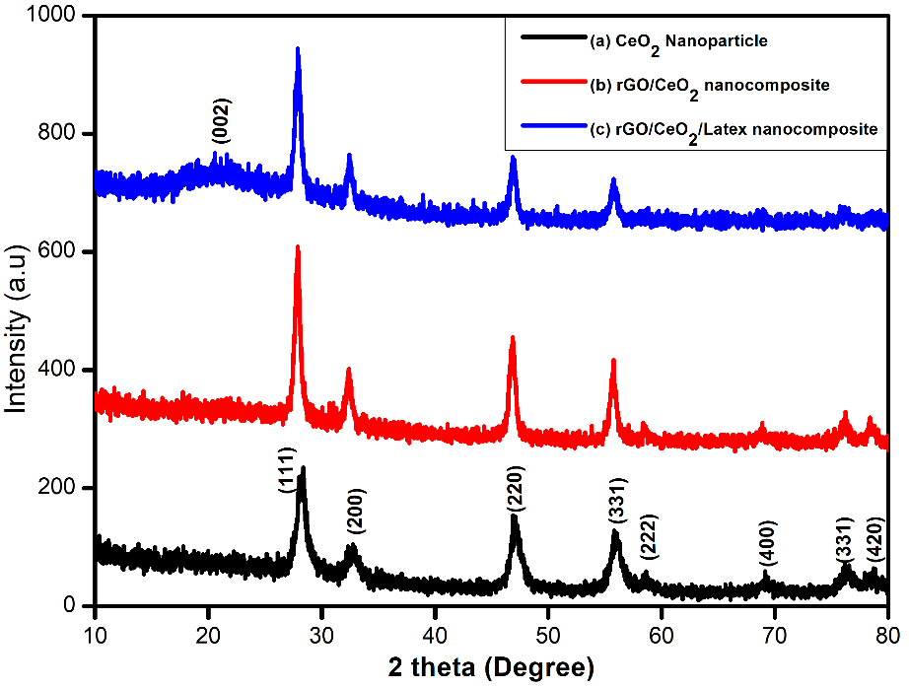

**Figure 1:** X-Ray Diffraction of (a) CeO2 Nanoparticle, (b) rGO/CeO2 nanocomposite and

(c) rGO/CeO2/Latex nanocomposite

**14**

**7.2 FT-IR studies:**

The FT-IR spectrum of rGO exhibits characteristic absorption bands at 1621 and 1050 cm-1 corresponding to bending vibration of absorbed water molecules and the contributions of sp2 characteristics. The FT-IR spectrum of CeO2 exhibits a band at 567 cm-1 corresponding to Ce-O vibration of the CeO2 crystal with bending hydroxyl group at 1652 cm-1 indicating presence of moisture in the sample. The characteristics peaks at 1650 cm-1 were noticed in both rGO/CeO2 and rGO/CeO2/Latex nanocomposites. The band at 523 cm-1 assigned to Ce-O vibration of the strong interaction between CeO2 nanoparticles and rGO and latex indicating anchored on the surface of nanoparticles.

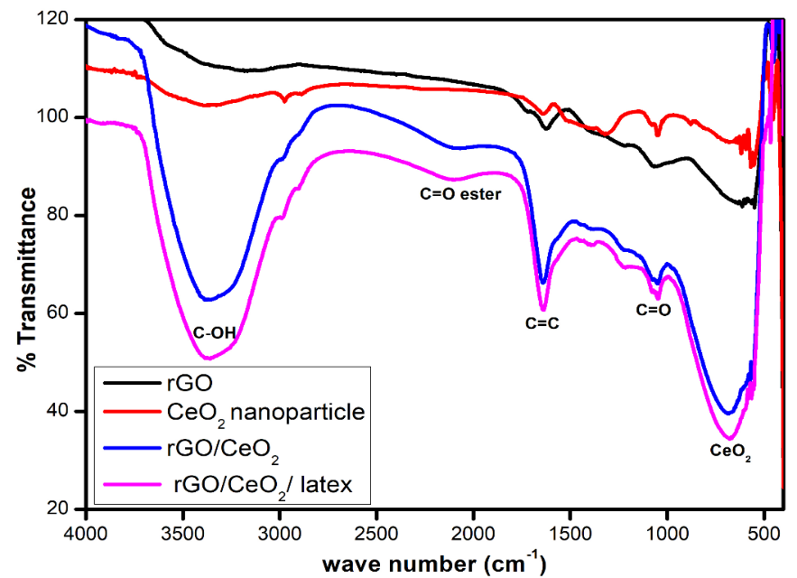

**Figure 2:** FTIR spectra analysis of procured electrode nanomaterials

**7.3 SEM analysis:**

The SEM images of CeO2 nanoparticles are aggregated form as shown in figure 3C. rGO is composed of wrinkled and layered thin platelet sheet like morphology figure 3(A-B), whereas, distribution of CeO2 nanoparticles anchored on surface of rGO seen in figure 3(C-D). This confirms the good combination of rGO

**15**

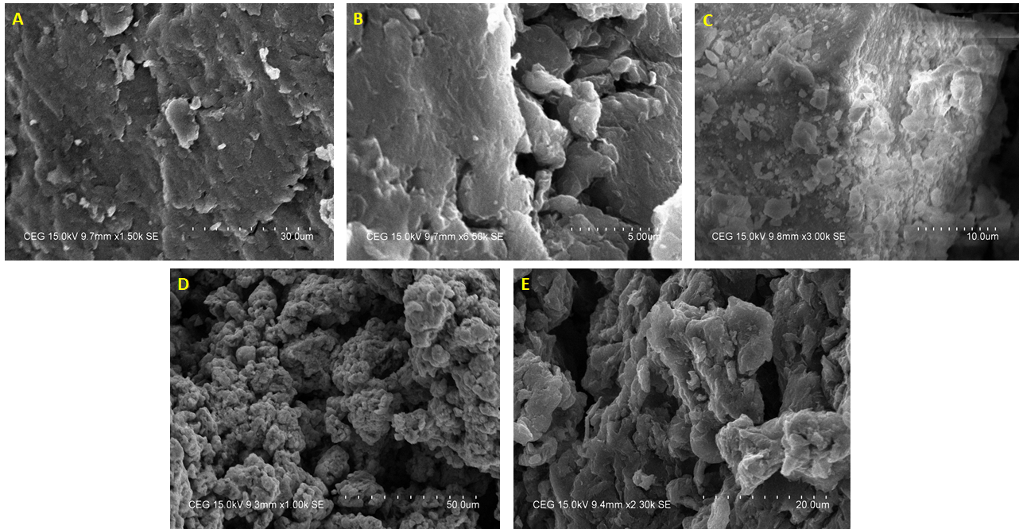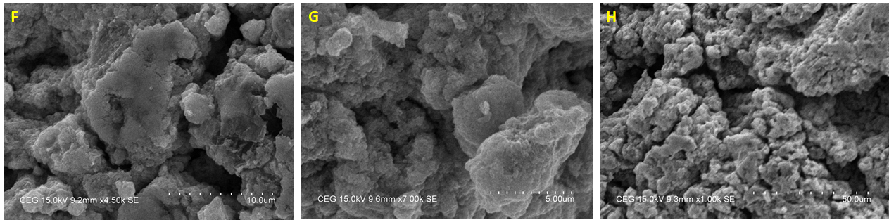and CeO2 nanocomposites. The agglomeration of CeO2 with pores behaviour was noticed in rGO/CeO2/Latex nanocomposites. This suggested that CeO2 formed as aggregated form with rGO and latex biomolecules preventing stacking of layers in rGO.

**Figure 3:** SEM images of (A-B) rGO sheets, (C) CeO2 nanoparticle, (D-E) rGO/CeO2 nanocomposite and (F-H) rGO/CeO2/Latex nanocomposite

**7.4 Electrochemical sensing**

**7.4.1 Cyclic voltammetry studies**

To ensure the redox activity[29] of the prepared sample the glassy carbon electrode (GCE) was drop casted with sample material is allowed to run in 0.1M FeCN3 electrolyte. The peak current in the figure.4 shows redox activity of the sample material.

**16**

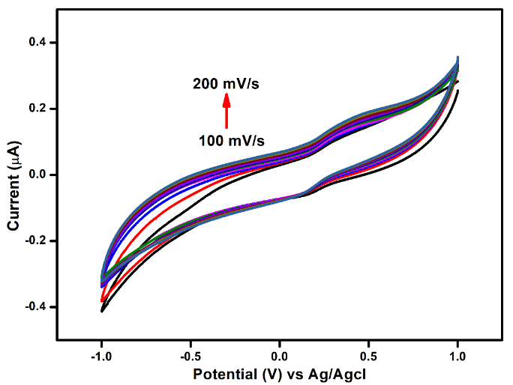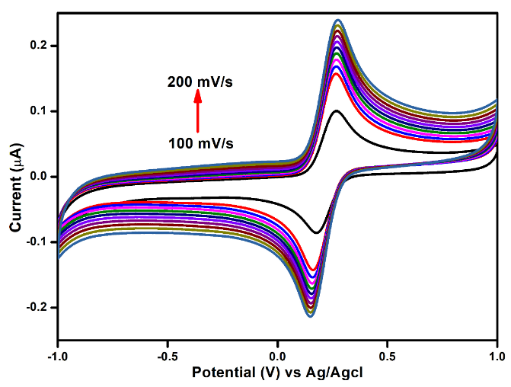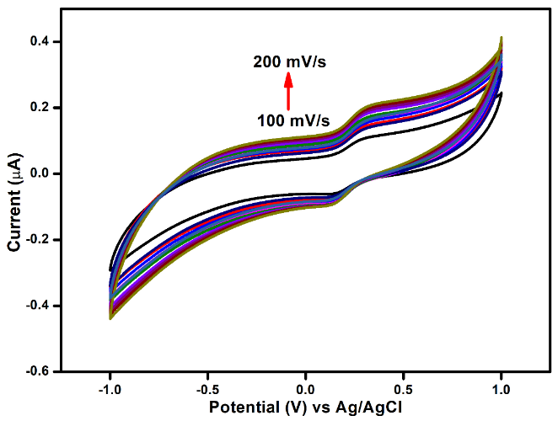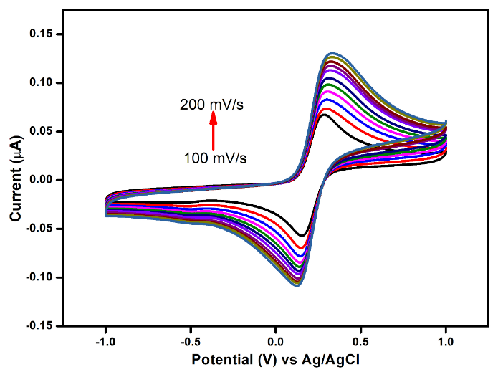

**(d)**

**(c)**

**(b)**

**(a)**

**Figure 4:** Ferrocyanide response of (a)GO modified GCE, (b)CeO2 modified GCE,

(c) rGO/CeO2 modified GCE, (d) rGO/CeO2/Latex modified GCE

**7.4.2. Square wave voltammetry studies:**

**Study 1: pH response on lead ions**

Various pH electrolyte solutions with lead ions were analysed using square wave voltammetry. The fig.5 shows the peak current obtained during SWV analysis. The peak that represents pH 5 in the graph shows highest peak current occurred at the range of pH 5 and the peak current reduced at pH ranges greater than 5. In previous work of SWV studies[30, 31] shows that optimum pH for lead detection is in the range of 4.5-5. Due to the highest peak current obtained, the pH 5 solution was chosen for the addition of different concentrations of lead ions to examine the sensitivity, LOD for rGO/CeO2/Latex nanocomposite.

**17**

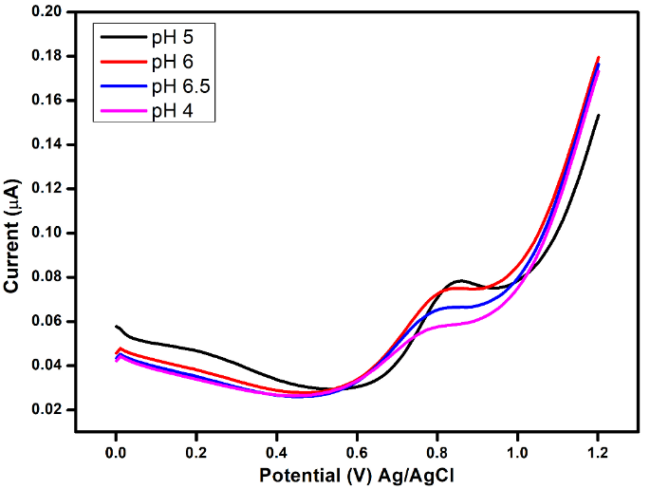

**Figure 5:** pH response of Lead ions using GO/CeO2/Latex modified GCE

**Study 2: Different lead concentrations on rGO/CeO2/Latex**

Different concentrations of lead ions in the electrolyte solution were analysed using SWV. From the concentration range of 170µg/L to 500µg/L, the lead ions were added to the electrolyte solution. Few concentrations in the increasing fashion were analysed using SWV and the graphs were shown in the fig. The fig.6 shows the peak current increases when the concentration of the lead ions in the solution was increased. The fig.7 shows, in the lead ion concentration of 500 µg/L the maximum peak current measured was 0.10µA. The sensitivity of rGO/CeO2/Latex nanocomposite can be examined using linearity between the lead ion concentration and the peak current. The correlation coefficient (R2) was determined to be 0.9942 and the limit of detection (LOD) was estimated to be 16.8 ng/L. From the slope of linearity, the sensitivity value was measured to be 1.74 pg/L/µA.

**18**

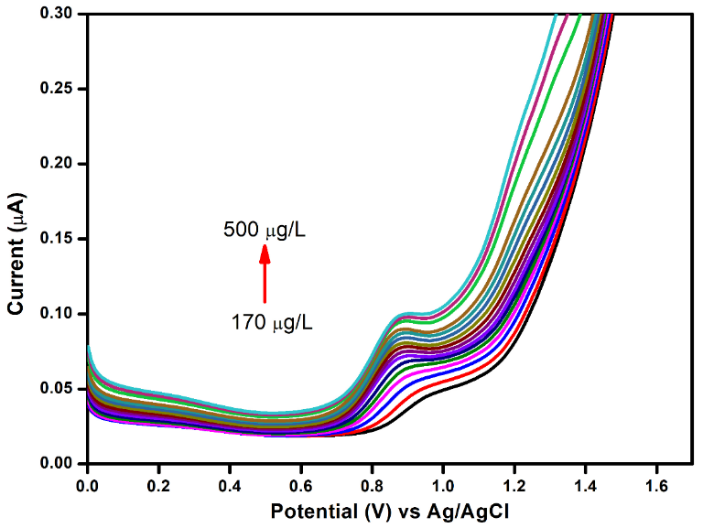

**Figure 6:** Square Wave Voltammetric sensing of Lead ions using GO/CeO2/Latex modified GCE

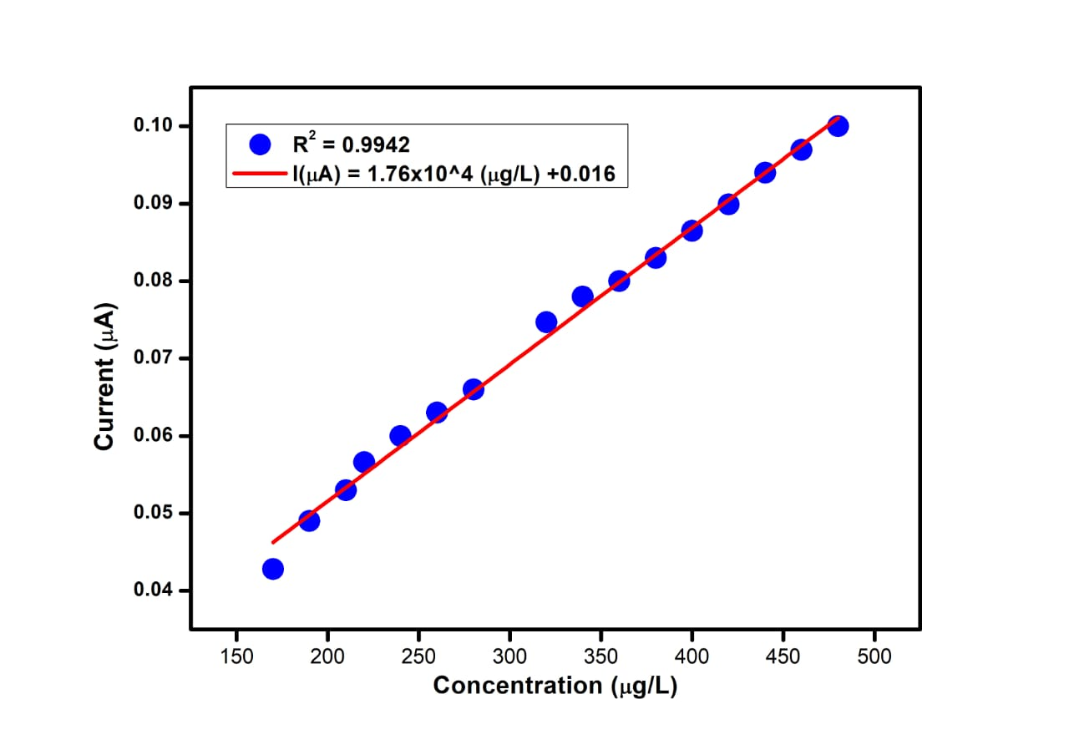

**Figure 7:** Linearly plotted graph against the lead ions concentration and peak current

**19**

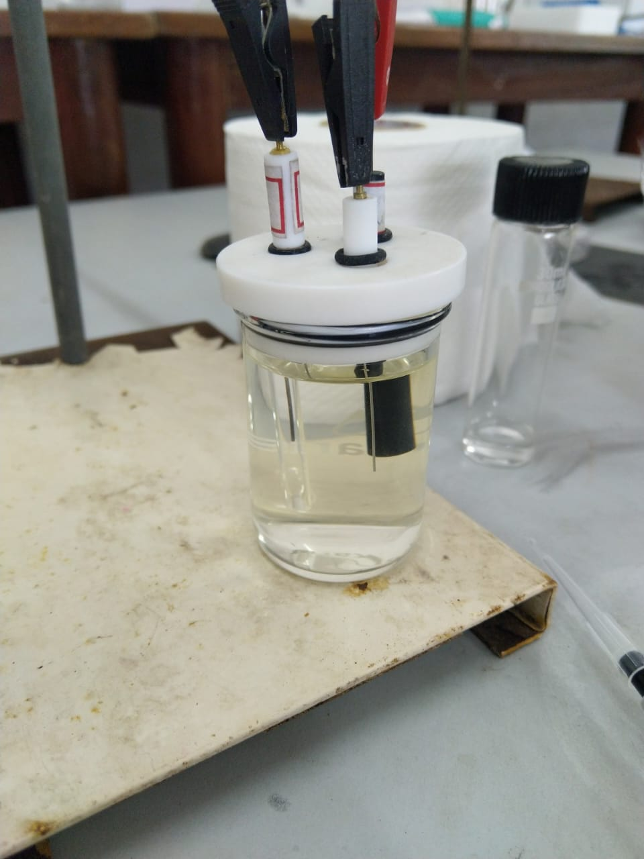

**Figure 8:** Experimental three electrode setup for cyclic voltammetry

and square wave voltammetry

**20**

**8. Conclusion**

From the above results its clearly demonstrate that hybridized rGO/CeO2 nanocomposite synthesized by simple green route method shows promising catalytic behaviour for lead ions detection. The properties of this nanocomposite was confirmed by XRD, FT-IR, SEM analysis. The LOD obtained was 16.8 ng/L and the sensitivity is found to be 1.76 pg/L/µA. As per the results of the work conducted, milky latex of *Calotropis gigantae* can be employed as a convenient reducing and capping agent for GO-CeO2.

**21**

**9. REFERENCES**

1. Sajid, M. and J. Płotka-Wasylka, *Nanoparticles: Synthesis, characteristics, and applications in analytical and other sciences.* Microchemical Journal, 2020. **154**: p. 104623.

2. De, M., P.S. Ghosh, and V.M. Rotello, *Applications of nanoparticles in biology.* Advanced Materials, 2008. **20**(22): p. 4225-4241.

3. Hasan, A., et al., *Nanoparticles in tissue engineering: applications, challenges and prospects.* International journal of nanomedicine, 2018. **13**: p. 5637.

4. Mitchell, M.J., et al., *Engineering precision nanoparticles for drug delivery.* Nature Reviews Drug Discovery, 2021. **20**(2): p. 101-124.

5. Sawan, S., et al., *Metal and metal oxide nanoparticles in the voltammetric detection of heavy metals: A review.* TrAC Trends in Analytical Chemistry, 2020. **131**: p. 116014.

6. Engwa, G.A., et al., *Mechanism and health effects of heavy metal toxicity in humans.* Poisoning in the modern world-new tricks for an old dog, 2019. **10**.

7. Vardhan, K.H., P.S. Kumar, and R.C. Panda, *A review on heavy metal pollution, toxicity and remedial measures: Current trends and future perspectives.* Journal of Molecular Liquids, 2019. **290**: p. 111197.

8. Singh, H., et al., *Recent advances in the application of noble metal nanoparticles in colorimetric sensors for lead ions.* Environmental Science: Nano, 2021. **8**(4): p. 863-889.

9. Sengan, M., R.K. Kamlekar, and A. Veerappan, *Highly selective rapid colorimetric sensing of Pb2+ ion in water samples and paint based on metal induced aggregation of N-decanoyltromethamine capped gold nanoparticles.* Spectrochimica Acta Part A: Molecular and Biomolecular Spectroscopy, 2020. **239**: p. 118485.

10. Hassan, K.M., G.M. Elhaddad, and M. AbdelAzzem, *Voltammetric determination of cadmium (II), lead (II) and copper (II) with a glassy carbon electrode modified with silver nanoparticles deposited on poly (1, 8-diaminonaphthalene).* Microchimica Acta, 2019. **186**(7): p. 1-10.

11. Sharifan, H., J. Moore, and X. Ma, *Zinc oxide (ZnO) nanoparticles elevated iron and copper contents and mitigated the bioavailability of lead and cadmium in different leafy greens.* Ecotoxicology and environmental safety, 2020. **191**: p. 110177.

12. Delmond, K.A., et al., *Antioxidant imbalance and genotoxicity detected in fish induced by titanium dioxide nanoparticles (NpTiO2) and inorganic lead (PbII).* Environmental Toxicology and Pharmacology, 2019. **67**: p. 42-52.

13. Singh, K.R., et al., *Cerium oxide nanoparticles: properties, biosynthesis and biomedical application.* RSC advances, 2020. **10**(45): p. 27194-27214.

**22**

14. Zhang, J.-W. and X. Zhang, *Electrode material fabricated by loading cerium oxide nanoparticles on reduced graphene oxide and its application in electrochemical sensor for tryptophan.* Journal of Alloys and Compounds, 2020. **842**: p. 155934.

15. Wu, Y., et al., *Facile design of cubic-like cerium oxide nanoparticles decorated reduced graphene oxide with enhanced microwave absorption properties.* Journal of Alloys and Compounds, 2020. **817**: p. 152766.

16. Wu, Y., et al., *Oxygen vacancies regulated microwave absorption properties of reduced graphene oxide/multi-walled carbon nanotubes/cerium oxide ternary nanocomposite.* Journal of Alloys and Compounds, 2020. **819**: p. 152944.

17. Shukla, A.K. and S. Iravani, *Green synthesis, characterization and applications of nanoparticles*. 2018: Elsevier.

18. Rana, A., K. Yadav, and S. Jagadevan, *A comprehensive review on green synthesis of nature-inspired metal nanoparticles: Mechanism, application and toxicity.* Journal of Cleaner Production, 2020. **272**: p. 122880.

19. Patil, S.P., *Calotropis gigantea assisted green synthesis of nanomaterials and their applications.* 2020.

20. Ahmad, S., et al., *Green nanotechnology: A review on green synthesis of silver nanoparticles—An ecofriendly approach.* International journal of nanomedicine, 2019. **14**: p. 5087.

21. Bandeira, M., et al., *Green synthesis of zinc oxide nanoparticles: A review of the synthesis methodology and mechanism of formation.* Sustainable Chemistry and Pharmacy, 2020. **15**: p. 100223.

22. Castillo-Henríquez, L., et al., *Green synthesis of gold and silver nanoparticles from plant extracts and their possible applications as antimicrobial agents in the agricultural area.* Nanomaterials, 2020. **10**(9): p. 1763.

23. Pugazhendhi, A., et al., *Anticancer, antimicrobial and photocatalytic activities of green synthesized magnesium oxide nanoparticles (MgONPs) using aqueous extract of Sargassum wightii.* Journal of Photochemistry and Photobiology B: Biology, 2019. **190**: p. 86-97.

24. Biswasroy, P., et al., *Pharmacological investigation of Calotropis gigantea: A benevolent herb of Nature.* Research Journal of Pharmacy and Technology, 2020. **13**(1): p. 461-467.

25. Chen, A. and B. Shah, *Electrochemical sensing and biosensing based on square wave voltammetry.* Analytical Methods, 2013. **5**(9): p. 2158-2173.

26. Paulchamy, B., G. Arthi, and B. Lignesh, *A simple approach to stepwise synthesis of graphene oxide nanomaterial.* J Nanomed Nanotechnol, 2015. **6**(1): p. 1.

27. Pujar, M.S., et al. *One-step synthesis and characterizations of cerium oxide nanoparticles in an ambient temperature via Co-precipitation method*. in *AIP Conference Proceedings*. 2018. AIP Publishing LLC.

**23**

28. Sagadevan, S., M. Johan, and J.A. Lett, *Fabrication of reduced graphene oxide/CeO2 nanocomposite for enhanced electrochemical performance.* Applied Physics A, 2019. **125**(5): p. 1-11.

29. Anambiga, I., et al. *Electrochemical sensor for the detection of lead ions*. in *International Conference on Advanced Nanomaterials & Emerging Engineering Technologies*. 2013. IEEE.

30. Lee, G.-J., H.-M. Lee, and C.-K. Rhee, *Bismuth nano-powder electrode for trace analysis of heavy metals using anodic stripping voltammetry.* Electrochemistry Communications, 2007. **9**(10): p. 2514-2518.

31. Fan, F., et al., *Determination of lead by square wave anodic stripping voltammetry using an electrochemical sensor.* Analytical Sciences, 2013. **29**(5): p. 571-577.

**24**